Biochemistry practice:

- What would be the molecular formula of a molecule made by linking 5 glucose molecules together?

- The R-group, or side chain, of the amino acid serine is –CH2-OH. The R-group, or side chain, of the amino acid leucine is –CH-(CH3)2. Where would you expect to find these amino acids in a globular protein located in an aqueous solution?

- If a DNA sample were composed of 10% thymine, what would be the percentage of guanine?

- How many peptide bonds are there in a pentapeptide?

- How many molecules of water would be needed to separate all monomers in a polysaccharide composed of 8 simple sugars?

- How many possible tripeptides can be made with the amino acids tyrosine, histidine and cysteine, if each peptide must contain all 3?

- How many dipeptides can be made from the 20 amino acids?

- If 500 glucose molecules are used to make starch, how many molecules of water would be produced in the condensation reactions?

- If a cellulose molecule consisted of 2000 glucose units, how many carbon, oxygen and hydrogen atoms would it contain?

Identify the following molecules:
10.
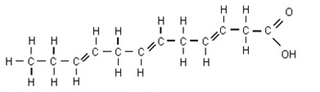

11.
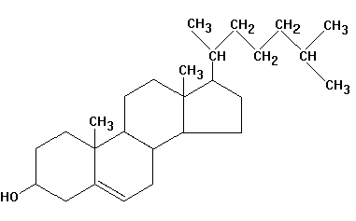

12.
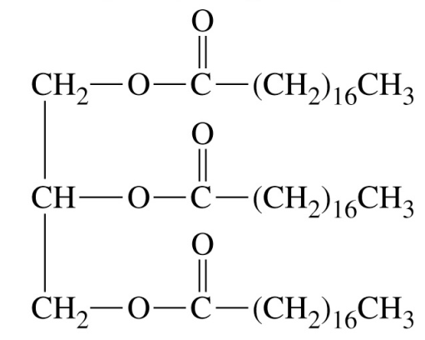

13.
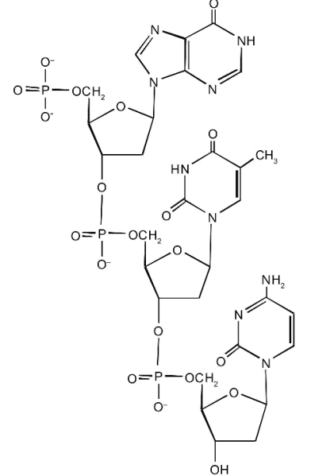

14.
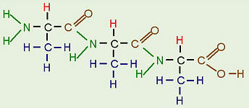

Identify the following amino acids as polar/nonpolar, and acidic or basic if applicable.
15. 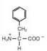

16.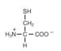

17. 