Carbohydrates
Monomer | Monosaccharides
Molecular Formulas | General: CH2O  Triose: C3H6O3  Pentose: C5H10O5  Hexose: C6H12O6
Common Functional Groups | Carbonyl:  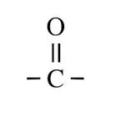  -Ketone:  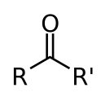  -Aldehyde:  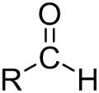  Hydroxyl:  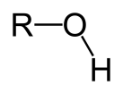
Disaccharide: 2 covalently bound monosaccharides  GLU + GLU = Maltose  GLU + GAL = Lactose  GLU + FRU = Sucrose | Polysaccharide: polymer, many covalently bound monosaccharides
Type of Reaction to form bond between Monomers | Dehydration Synthesis: water molecule removed (-OH from one, -H from the other)  This type of bond is called: glycosidic linkage  These bonds are named based on:  - alpha or beta orientation of the hydroxyl groups on the anomeric carbon atoms  - the two carbon atoms that bind the oxygen holding the molecules together, C-1 and C-4, respectively
Type of Reaction to Break bond between Monomers | Hydrolysis: Addition of a water molecule, -OH to one monomer and -H to the other, to sever the bond between them
Functions of polysaccharides | 1) Storage (energy, parts for synthesis of other molecules)  2) Structure
Structural polysaccharides (glucose)  (type of bond, distinct features, digestible by humans?) | 1) Cellulose: beta- 1, 4 linkage, straight shape, plant cell walls, paper, cotton, not digestible in organisms without proper gut microbes  2) Chitin: beta- 1, 4 linkage, straight shape, arthropod exoskeletons and fungi cell walls, have an N-acetyl group attach to each monomer, not digestible in organisms without proper gut microbes
Storage polysaccharides (glucose)  (type of bond, distinct features, digestible by humans?) | 1) Starch: alpha- 1, 4 linkage, used in plants to store glucose, helical shape, digestible  -2 forms: amylose (unbranched), amylopectin (branched, attachments 1-6 linkages)  2) Glycogen: alpha- 1, 4 linkage, used in humans to store glucose, highly branched (attachments 1-6 linkages), helical shape
Linear structure of B-Glucose | Ring Structure of B-Glucose

