Lipids
Monomer/Polymer | None, lipids are not big enough to be considered polymers
Fats
Components:  -1 Glycerol molecule  -3 Fatty Acids  Properties: Hydrophobic | Functional Groups:  -Hydroxyl  -Carboxyl
Method of construction:  Dehydration synthesis x3  Method of destruction:  Hydrolysis | Linkage: Ester linkage
Saturated: hydrocarbon chain completely saturated with Hydrogen atoms  Unsaturated: 1 or more double bonds between C atoms, replace H atoms in hydrocarbon chain  -Cis: Hydrogens on same side  -Trans: Hydrogens staggered | Functions:  -Energy storage: stored in adipose cells for energy  -Protection: maintain body temp, cushion organs
Phospholipids
Components:  - 1 glycerol molecule  - 2 fatty acids  - 1 phosphate group (- charge)  -small additional polar molecule  Properties:  -Hydrophilic head (phosphate group)  -Hydrophobic tails (hydrocarbon chains) | Function groups: hydroxyl, carboxyl  -Phosphate Group:
Function: Cell membrane
Steroids
Components:  - 4 fused rings  - distinguishing chemical groups attached  to rings | Structure:  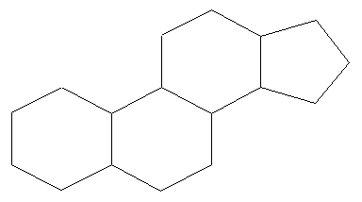
Function: Component of cell membrane, hormones (made in liver, obtained from diet)

