Proteins
Monomer: | Amino Acids (20)
Polymer: | Polypeptide
Amino Acids  Functional groups  and  Common Structure: | Uncharged:  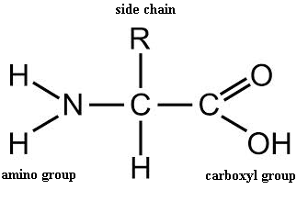  Charged:  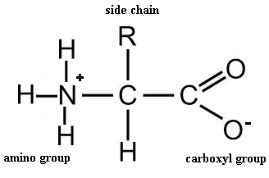
Side Chains and Properties:  (common compositions) | 1) Polar: hydrophilic  2HN-C=O, -OH, -SH  2) Non-polar: hydrophobic  Hydrocarbons  3) Charged: polar, hydrophilic  -Acidic: -Basic  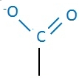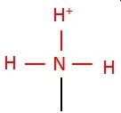
Reaction to Form Polypeptides: | Dehydration Synthesis
Type of Bond formed: | Peptide Bond  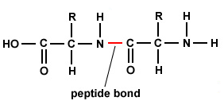
4 Levels of Structure
Primary: | Linear amino acid sequence
Secondary: | Backbone interactions: Hydrogen bonding  -Alpha Helix: H-bonds between every 4th amino acid in polypeptide, helical coil  -Beta Pleated Sheet: H-bonds between parallel segments of polypeptide, pleated sheet
Tertiary: | Side chain interactions:  -Hydrophobic: nonpolar side chains aggregate, van der Waals interactions ensue  -Polar: H-bonds between side chains  -Ionic bonds  -Disulfide Bridges: between two cysteine side chains with sulfhydryl groups (-SH HS- -----> S-S)
Quaternary: | Interactions between two or more polypeptides
Chaperonins: | Proteins that assist in the proper folding of a polypeptide by shielding it from the cellular environment
Denaturation:  Causes & Effects | The unfolding of a protein that results in loss of functionality.  -Change in pH, salt concentration, temperature  -Exposure to chemicals or nonpolar solvent
Diseases Associated with Misfolding: | Cystic Fibrosis, Alzheimer's, Parkinson's, Sickle Cell Anemia
Protein Functions: | Enzymes, Transport, Contractile/Motor, Storage, Hormonal, Receptor, Protection, Structure

